Appendix

New and Existing Nameplate of “Shite” Hot-rolled Ribbed Bars

Front of new namplate Back of new nameplate
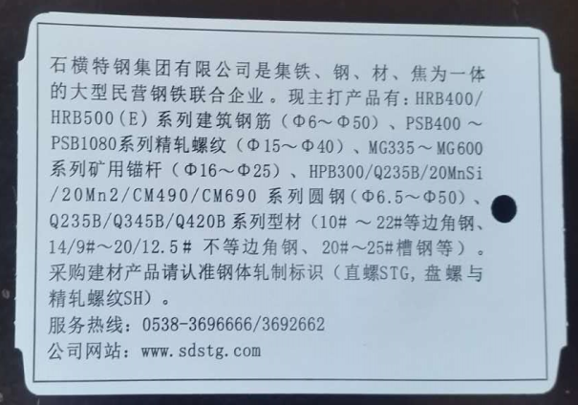
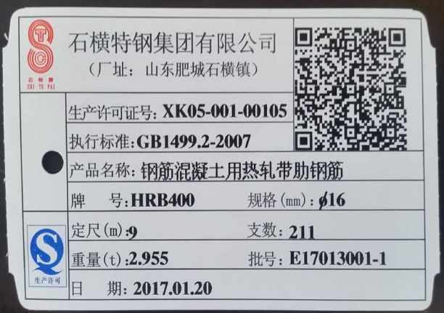

Front of existing nameplate Back of existing nameplate

