期货日报：期现结合为有色经营锦上添花

Futures Daily: The Combination of Futures and Spot Goods Promoted the Development of Non-ferrous Metal Business
Updated on: July 10, 2017
Reported by Han Yufu, Journalist from Futures Daily
Enhance corporate resistance to risk and achieve stable and sustainable development
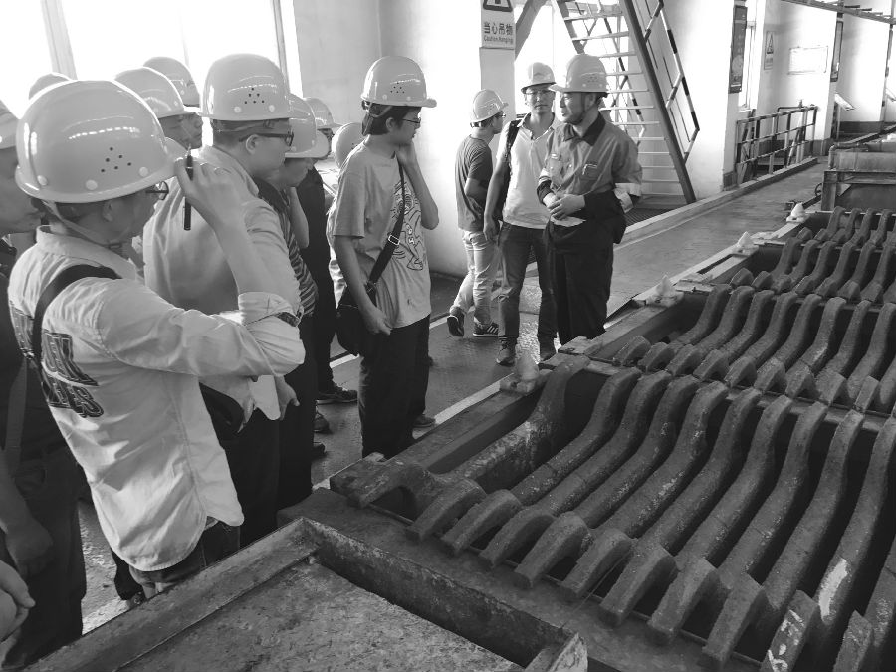

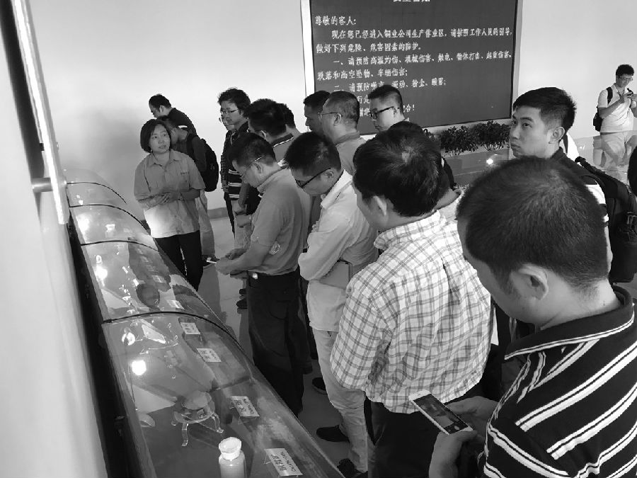
The non-ferrous metal market fluctuated in the first half of 2017, but it was not affected by off-season demand and experienced a rapid rally in the case of generally strong supply in June. Under such circumstances, the journalist from Futures Daily followed the research group of Shanghai Futures Exchange (SHFE) to Gansu Province, a concentrated non-ferrous metal smelting area in China, and visited Aluminum Corporation of China Limited Lanzhou Branch (hereinafter referred to as Chalco Lanzhou Branch) and other high-end non-ferrous product suppliers. Through research, the journalist found that futures had become an important tool for capital management of non-ferrous metal enterprises and had greatly improved the business model of the enterprises. This research is the first term of 2017 non-ferrous metal training base held by SHFE and Shenzhen Futures Association, which combines theory and practices. Futures firms and representatives of non-ferrous metal enterprises in Guangdong Province participated in the activity.
The non-ferrous metal market may experience violent fluctuations in the second half of the year
The non-ferrous metal market fluctuated in the first half of 2017, rising first, then declining and then increasing again. Industry insiders believe that the prices of copper, aluminum, nickel and other basic non-ferrous metals will fluctuate again in the second half of the year due to the landing of policies, the imbalance between supply and demand and other factors in China.
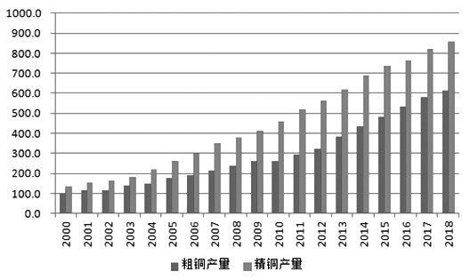

Crude copper output
Refined copper output

The figure shows crude copper and refined copper output in China (unit: 10,000 tons)
In terms of copper price, Antaike Senior Engineer He Xiaohui said, "Due to a slowdown in the future copper production and copper consumption growth and increased uncertainties, copper price will experience significant fluctuations in a range in the second half of the year."
In He Xiaohui's opinion, due to the small number of large-scale copper mine projects under construction in recent years, there is still room for the growth of refined copper output in China, but the room is very limited, and copper output growth also tends to slow down consequently. In addition, the peak of China's copper smelting capacity growth has passed, and the average growth rate of crude copper and refined copper output is gradually falling to single digits, so the future growth of China's copper output is limited.
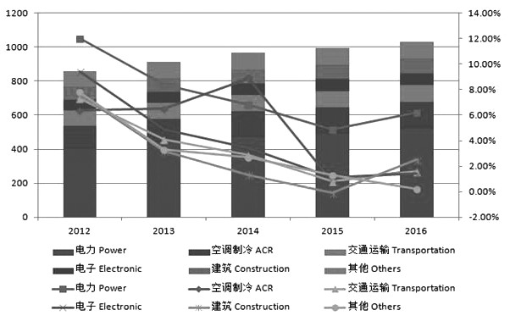
The figure shows China's refined copper consumption structure and industry-based growth rate
From the perspective of copper consumption, the power industry will still be the major copper consumer in China. However, considering that the current growth of grid investment has dropped to single digits and marginal consumer demand shows a continuously declining trend, He Xiaohui believed that it was difficult to have a significant increase in copper consumption growth in the second half of the year.
Overall, there is no obvious contradiction between the domestic copper supply and demand in the second half of the year. However, in view of the sudden and perplexing changes in the macro environment in the second half of the year, the accelerated balance sheet reduction by the Federal Reserve, deepened financial deleveraging in China and other factors may have some bad impact on copper price, and the possible capital and debt problems arising from financial deleveraging will have a profound impact on copper that has strong financial property. Therefore, He Xiaohui believed that copper price would significantly fluctuate in a range in the second half of the year.
"In the second half, aluminum price will be mainly affected by the implementation of domestic policies." The person in charge of marketing of Chalco Lanzhou Branch said that although the market was suppressed by the normal of financial high inventory and other factors in a short term, with the gradual implementation of the environmental protection and de-capacity policies and the policies on cleaning up illegal production capacity, the situation may be the same as last year's cut in coal production capacity, thus providing effective support for aluminum price.
The abovementioned person believed that in the stage when policy implementation was still pending, the main Shanghai aluminum contract would narrowly fluctuate in the range of 13,500 yuan/ton to 15,000 yuan/ton in the third quarter; however, the environmental protection and de-capacity policies would be implemented smoothly in the fourth quarter. Due to the strong constraints of policies after they were implemented, there would be changes in the domestic long-term excessive capacity. Coupled with the domestic and foreign trend of macro recovery, it was likely to lead to bullish sentiment on the domestic and foreign aluminum market, and aluminum price was expected to increase to more than 15,000 yuan/ton in late 2017.
In the opinion of CITICS Futures Non-ferrous Metal Research Director Wu Kai, the domestic nickel price might fluctuate to the bottom in the third quarter due to the impact of recent slowdown in terminal demand, and the price in the fourth quarter depended on whether manufacturing enterprises drastically reduced their production in the price fall in the third quarter. If production was significantly reduced, nickel price might stabilize and rebound.
The futures market has been inseparable from business operation
The journalist from Futures Daily learned that as the first batch of enterprises using futures for hedging, the non-ferrous metal enterprises had undergone fundamental changes in their understanding of hedging and the traditional spot preservation theory had developed into the modern spot market-combined portfolio investment theory. To some extent, the futures market has become an important asset management tool for enterprises.
For example, in the current non-ferrous metal industry, the pricing of both upstream and downstream raw materials and products can reflect the connection between operation and futures. Most of the domestic enterprises related to the production, processing and trading of non-ferrous metals and precious metals and other areas settle raw materials procurement and product sales based on futures market pricing (quotation price and daily settlement price), monthly average price, etc.
In essence, it is a flexible use of the pricing mechanism of the futures market. At the same time, the highly open, fair, impartial and authoritative raw material and product prices provided by the futures market are also used for risk management assessment of enterprises. To some extent, the futures market has been inseparable from business operation for the non-ferrous metal enterprises, and it has made great contributions to the maximization of corporate investment profits.
As the largest nickel and cobalt production base and the third largest copper production enterprise in China, Jinchuan Group is one of the earliest go-out enterprises in Gansu Province. It has long been engaged in domestic and overseas futures business, so it has a lot worthy of reference in terms of futures and spots-combined hedging and risk management.
According to the person in charge of Jinchuan Group, currently, the company adopted the hedging management model integrating net exposure characterized by "spot hedging and margin hedging" and "cash flow hedging (constant inventory)", that is, the spot market is first used to hedge against the price risk of purchase-side raw materials and sales-side products, and positions will be established in the futures market for hedging only when there is quantity or time risk exposure in supply and sale.
In his view, the company has effectively avoided various market risks, enhanced corporate resistance to risks and achieved stable and sustainable development through the futures and spots-combined risk prevention and asset hedging model.
Although the effectiveness of this model has been verified in practice, it does not mean that this model is the most effective and can be applied to any non-ferrous metal enterprise. An insider told the journalist that hedging models did not have absolute advantages and disadvantages, and what mattered was whether they were suitable. Enterprises should develop their own hedging model based on their operation conditions, profit model and business philosophy, and they should also make it clear that the essence of hedging is to avoid risks rather than speculation.
The audit system is expected to be further implemented
Although participating in futures hedging can reduce the business risks of enterprises, more and more non-ferrous metal enterprises have found that the specific rules of the existing hedging management assessment standards have not been fully implemented, which causes frequent inquiries from regulatory authorities. Therefore, industry insiders appealed the relevant departments to strengthen the guidance on hedging auditors to ensure the full implementation of the audit system.
An insider told the Futures Daily journalist that currently supply-side hedging was difficult mainly because there were generally problems in the current futures management assessment standards, entities were in a weak position in futures market participation, etc. He said, "The so-called weak position of entities in futures market participation refers to the lack of hedging 'hardware' of entities, namely the shortage of funds and professionals, while Group operation of hedging can better allocate group assets, thus enhancing the market competitiveness of subordinate enterprises and even the Group."
In addition, there are also problems in the current enterprise hedging management standards, and the core problem is that audit institutions still separate futures from spot goods in settlement when auditing enterprise hedging results.
In fact, hedging itself is the result of the combination of the spot market and the futures market. In essence, it refers to that the spot market and the futures market carry out sales activities with the same quantity but in the opposite direction for the same kind of goods. It is based on the principle that generally the futures market and the spot market have the similar trend, and its purpose is to use the profits of a market to offset the losses of the other market so as to lock profits and maintain value.
If futures are separated from spots in settlement, except for the extremely special circumstance where futures price and spot price show opposite trends, there must be losses in the corporate account book of futures or spots. After audit institutions report the results, enterprises will be faced with inquiries from regulatory authorities. If things go on like this, great inconvenience will be brought to enterprises.
However, if enterprises don't participate in the futures market, although they will not be under the pressure of repeated inquires from regulatory authorities, their development will be restricted due to lack of competitiveness. After all, after the listing of futures varieties in the futures market, the original spot pricing model of relevant industries will be broken and replaced, and the competition model will transform itself from one-on-one competition into the invisible one-on-multiple competition. An enterprise not participating in the futures market is similar to a person losing one leg, and it will lack competitiveness due to mutilated "limbs", thus affecting its future development.

