会员接入指引
本章结合会员远程交易接入现状和交易所会员接入规范就会员接入和备份方式以及有关路由配置进行指导性阐述。
上期所要求会员每个席位直连双线路接入，因此不再支持间连席位接入模型。本章仅提供直连+间连席位接入的两种推荐接入方式（报盘机多网卡或路由器NAT+HSRP方式）的配置参考。
本章中的配置范例仅用于说明和描述用途，会员应根据自身设备、软件和链路情况进行个性化配置。

直连+间连席位接入方式一（报盘机多网卡）
直连+间连席位为同时直连上期所大厦、张江数据中心和其他交易所的会员远程交易席位：正常情况下使用直连线路访问上期所期货大厦和张江数据中心，使用三所联网或中金所联网访问上期所北京数据中心；直连线路故障时使用三所联网或中金所联网访问上期所期货大厦和张江数据中心。
目前直连席位有三种接入方式：
- 专线接入：此类席位使用SDH或ATM线路分别接入到大厦数据中心或张江数据中心。
- 大厦局域网接入：此类席位使用期货大厦局域网接入到大厦数据中心。
- 拨号接入席位：此类席位可通过拨号接入期货大厦、张江及北京数据中心实现冗余互备。
间连席位接入为使用大商所、郑商所或中金所直连线路通过交易所间的互联高速专线实现访问。
报盘机多网卡方式应使用如下模式接入：
- 冗余链路：申请两条不同运营商的专线分别接入上期所期货大厦和张江数据中心，第三条专线接入到大商所、郑商所、中金所。
- 多个报盘机（多个网卡）：每个报盘机采用多网卡接入（网卡1配置大厦接入地址；网卡2配置张江接入地址；网卡3配置DCE、CZCE或者CFFEX接入地址）。配置一套相同的报盘机作为备份。NGES交易系统的FENS组件会根据会员报盘机地址返回给报盘机交易前置机的地址列表。
- 多台路由器和交换机：每台路由器连接不同通讯链路；交换机分别接入路由器和报盘机。
假设会员远程交易席位以路由器ROUTER-A接入到大厦数据中心；以路由器ROUTER-B直连张江数据中心；以路由器ROUTER-C直连大商所。

地址分配
会员路由器 | 会员广域网接口地址分配 | 会员局域网地址分配
ROUTE-A | 10.32.1.0/30 | 10.44.1.0/24
ROUTE-B | 10.64.1.0/30 | 10.66.1.0/24
ROUTE-C | 10.2.1.0/30 | 10.2.2.0/24

网络拓扑图
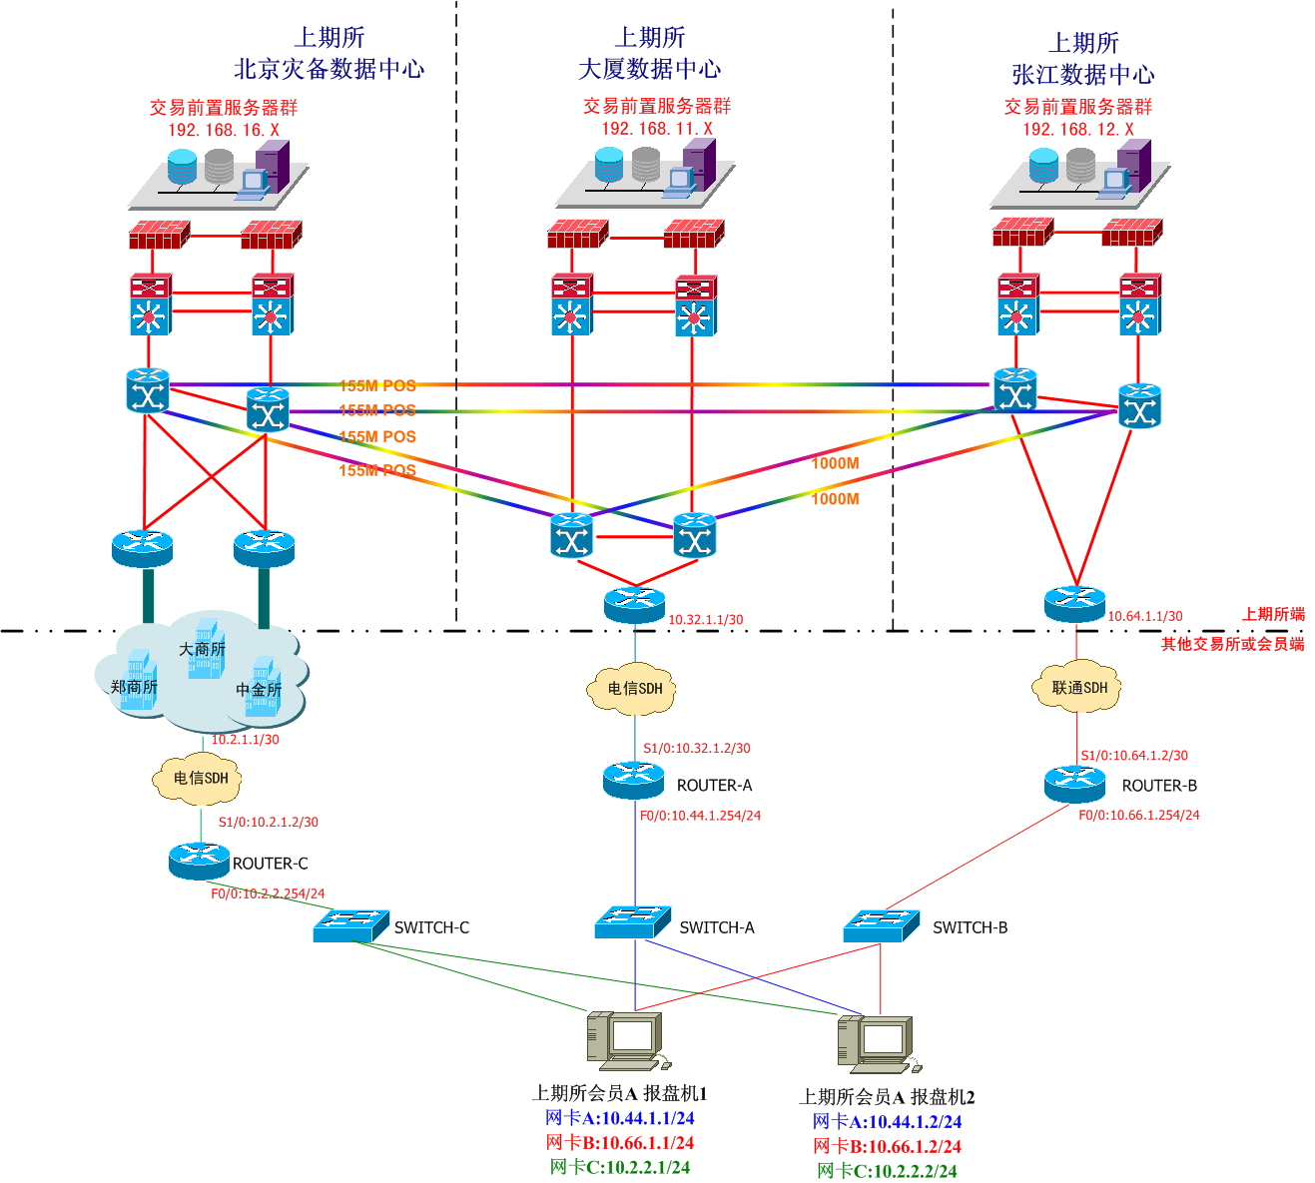
图表 1 直连+间连席位（报盘机多网卡方式）网络拓扑图

路由器配置
路由器ROUTE-A的配置如下：
Hostname ROUTER-A
!广域网配置
Interface serial1/0
Description To_SHFE_QHDS_运营商-线路编号
Ip address 10.32.1.2 255.255.255.252
!局域网配置
Interface F0/0
Description To_SwitchA_xxx
Ip address 10.44.1.254 255.255.255.0
!路由配置
Ip route 192.168.11.0 255.255.255.0 Serial1/0 10.32.1.1 name SHFE-DS-FRONT
Ip route 192.168.9.0 255.255.255.0 Serial1/0 10.32.1.1 name SHFE-DS-MEMBER
Ip route 192.168.12.0 255.255.255.0 Serial1/0 10.32.1.1 name SHFE-ZJ-FRONT
Ip route 192.168.13.0 255.255.255.0 Serial1/0 10.32.1.1 name SHFE-ZJ-MEMBER
IP route 192.168.16.0 255.255.255.0 serial1/0 10.32.1.1 name SHFE-BJ-FRONT
Ip route 192.168.17.0 255.255.255.0 serial1/0 10.32.1.1 name SHFE-BJ-MEMBER
Ip route 172.30.0.0 255.255.0.0 Serial1/0 10.32.1.1 name CFFEX
Ip route 129.10.0.0 255.255.0.0 Serial1/0 10.32.1.1 name CZCE
Ip route 10.10.2.0 255.255.255.0 Serial1/0 10.32.1.1 name DCE
//注：静态路由配置时建议同时写上下一跳IP地址和接口名称，防止路由异常。

路由器ROUTE-B的配置如下：
Hostname ROUTER-B
!广域网配置
Interface serial1/0
Description To_SHFE_Zhangjiang_运营商-线路编号
Ip address 10.64.1.2 255.255.255.252
!局域网配置
Interface F0/0
Description To_SwitchB_xxx
Ip address 10.66.1.254 255.255.255.0
!路由配置
Ip route 192.168.11.0 255.255.255.0 Serial1/0 10.64.1.1 name SHFE-DS-FRONT
Ip route 192.168.9.0 255.255.255.0 Serial1/0 10.64.1.1 name SHFE-DS-MEMBER
Ip route 192.168.12.0 255.255.255.0 Serial1/0 10.64.1.1 name SHFE-ZJ-FRONT
Ip route 192.168.13.0 255.255.255.0 Serial1/0 10.64.1.1 name SHFE-ZJ-MEMBER
IP route 192.168.16.0 255.255.255.0 serial1/0 10.64.1.1 name SHFE-BJ-FRONT
Ip route 192.168.17.0 255.255.255.0 serial1/0 10.64.1.1 name SHFE-BJ-MEMBER
Ip route 172.30.0.0 255.255.0.0 Serial1/0 10.64.1.1 name CFFEX
Ip route 129.10.0.0 255.255.0.0 Serial1/0 10.64.1.1 name CZCE
Ip route 10.10.2.0 255.255.255.0 Serial1/0 10.64.1.1 name DCE
//注：静态路由配置时建议同时写上下一跳IP地址和接口名称，防止路由异常。

路由器ROUTE-C的配置如下：
Hostname ROUTER-C
!广域网配置
Interface serial1/0
Description To_DCE_运营商-线路编号
Ip address 10.2.1.2 255.255.255.252
!局域网配置
Interface F0/0
Description To_SwitchC_xxx
Ip address 10.2.2.254 255.255.255.0
！路由配置
Ip route 192.168.11.0 255.255.255.0 Serial1/0 10.2.1.1 name SHFE-DS-FRONT
Ip route 192.168.9.0 255.255.255.0 Serial1/0 10.2.1.1 name SHFE-DS-MEMBER
Ip route 192.168.12.0 255.255.255.0 Serial1/0 10.2.1.1 name SHFE-ZJ-FRONT
Ip route 192.168.13.0 255.255.255.0 Serial1/0 10.2.1.1 name SHFE-ZJ-MEMBER
IP route 192.168.16.0 255.255.255.0 serial1/0 10.2.1.1 name SHFE-BJ-FRONT
Ip route 192.168.17.0 255.255.255.0 serial1/0 10.2.1.1 name SHFE-BJ-MEMBER
Ip route 172.30.0.0 255.255.0.0 Serial1/0 10.2.1.1 name CFFEX
Ip route 129.10.0.0 255.255.0.0 Serial1/0 10.2.1.1 name CZCE
Ip route 10.10.2.0 255.255.255.0 Serial1/0 10.2.1.1 name DCE
//注：静态路由配置时建议同时写上下一跳IP地址和接口名称，防止路由异常。

直连+间连席位接入方式二（NAT+HSRP）
报盘机如果采用多网卡方式，报盘机本身路由配置会较为复杂，且无法实现网络层面的自动切换，因此可考虑采用NAT+HSRP方式。通过HSRP组实现网络链路故障的自动冗余切换。
NAT+HSRP方式应使用如下模式接入：
- 冗余链路：申请两条不同运营商的专线分别接入上期所期货大厦和张江数据中心，第三条专线接入到大商所、郑商所、中金所。
- 多个报盘机（二个网卡）：每个报盘机采用双网卡接入（双网卡绑定实现冗余）。配置一套相同的报盘机作为备份。
- 多台路由器和交换机：每台路由器连接不同通讯链路；交换机分别接入路由器和报盘机。直连上期所的两台路由器使用NAT+HSRP技术实现网关冗余切换。直连其他交易所的路由器使用NAT实现互联。
- NGES交易系统的FENS组件会根据会员报盘机地址返回给报盘机交易前置机的地址列表。
假设会员远程交易席位以路由器ROUTER-A接入到大厦数据中心；以路由器ROUTER-B直连张江数据中心；以路由器ROUTER-C直连大商所。

地址分配
会员路由器 | 会员广域网接口地址分配 | 会员局域网地址分配
ROUTE-A | 10.32.1.0/30 | 10.44.1.0/24
ROUTE-B | 10.64.1.0/30 | 10.66.1.0/24
ROUTE-C | 10.2.1.0/30 | 10.2.2.0/24

网络拓扑图
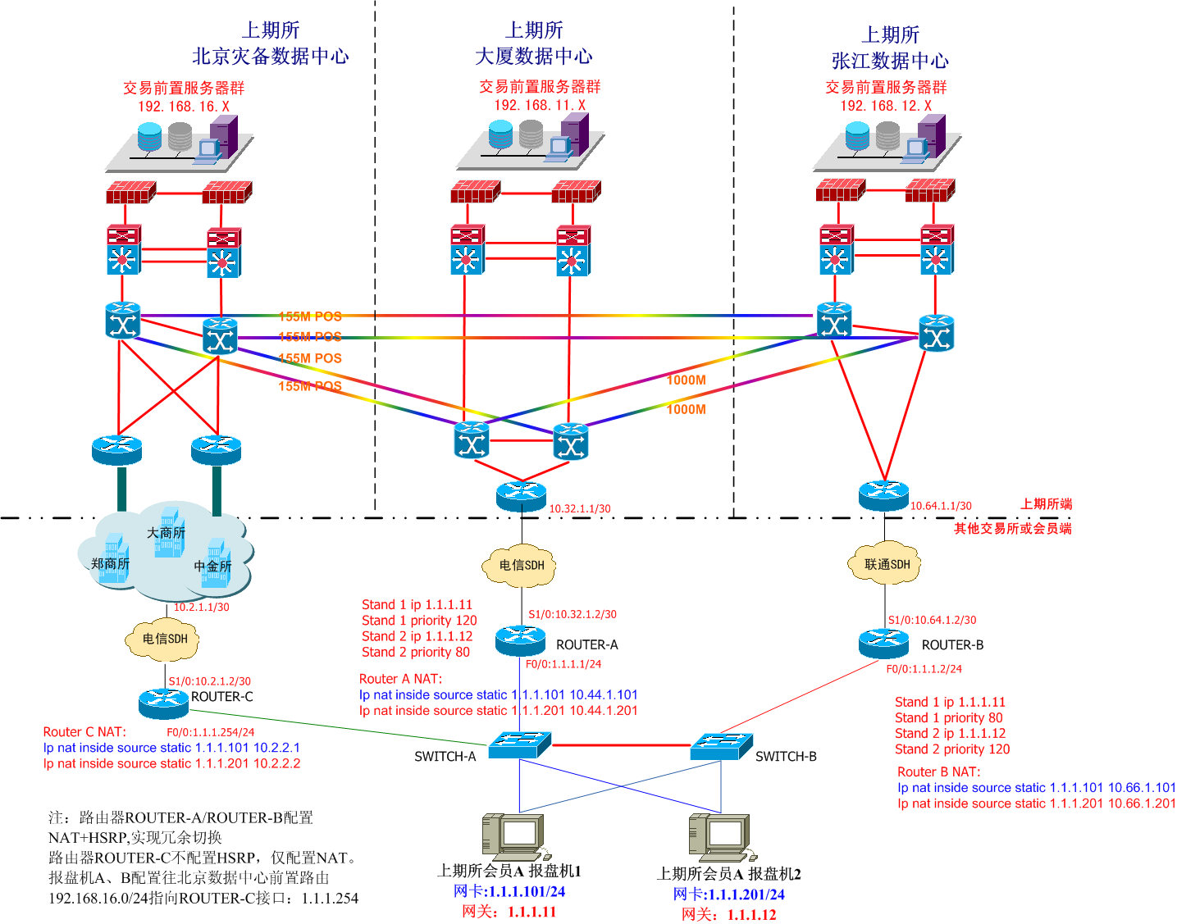
图表 8 直连+间连席位（NAT+HSRP方式）网络拓扑图

路由器配置
路由器ROUTE-A的配置如下：
Hostname ROUTER-A
!广域网配置
Interface serial1/0
Description To_SHFE_QHDS_运营商-线路编号
Ip address 10.32.1.2 255.255.255.252
!局域网配置
Interface F0/0
Description To_SwitchA_xxx
Ip address 1.1.1.1 255.255.255.0
！HSRP配置
Interface F0/0
Standby 1 ip 1.1.1.11
Standby 1 priority 120
Standby 1 track s1/0
Standby 1 preempt
Standby 2 ip 1.1.1.12
Standby 2 priority 80
Standby 2 track s1/0
Standby 2 preempt
!NAT配置
Interface serial1/0
Ip nat outside
Int f0/0
Ip nat inside
Ip nat inside source static 1.1.1.101 10.44.1.101
Ip nat inside source static 1.1.1.201 10.44.1.201
!路由配置
Ip route 192.168.11.0 255.255.255.0 Serial1/0 10.32.1.1 name SHFE-DS-FRONT
Ip route 192.168.9.0 255.255.255.0 Serial1/0 10.32.1.1 name SHFE-DS-MEMBER
Ip route 192.168.12.0 255.255.255.0 Serial1/0 10.32.1.1 name SHFE-ZJ-FRONT
Ip route 192.168.13.0 255.255.255.0 Serial1/0 10.32.1.1 name SHFE-ZJ-MEMBER
IP route 192.168.16.0 255.255.255.0 serial1/0 10.32.1.1 name SHFE-BJ-FRONT
Ip route 192.168.17.0 255.255.255.0 serial1/0 10.32.1.1 name SHFE-BJ-MEMBER
Ip route 172.30.0.0 255.255.0.0 Serial1/0 10.32.1.1 name CFFEX
Ip route 129.10.0.0 255.255.0.0 Serial1/0 10.32.1.1 name CZCE
Ip route 10.10.2.0 255.255.255.0 Serial1/0 10.32.1.1 name DCE
//注：静态路由配置时建议同时写上下一跳IP地址和接口名称，防止路由异常。

路由器ROUTE-B的配置如下：
Hostname ROUTER-B
!广域网配置
Interface serial1/0
Description To_SHFE_Zhangjiang_运营商-线路编号
Ip address 10.64.1.2 255.255.255.252
!局域网配置
Interface F0/0
Description To_SwitchB_xxx
Ip address 1.1.1.2 255.255.255.0
！HSRP配置
Interface F0/0
Standby 1 ip 1.1.1.11
Standby 1 priority 80
Standby 1 track s1/0
Standby 1 preempt
Standby 2 ip 1.1.1.12
Standby 2 priority 120
Standby 2 track s1/0
Standby 2 preempt
!NAT配置
Interface serial1/0
Ip nat outside
Int f0/0
Ip nat inside
Ip nat inside source static 1.1.1.101 10.66.1.101
Ip nat inside source static 1.1.1.201 10.66.1.201
!路由配置
Ip route 192.168.11.0 255.255.255.0 Serial1/0 10.64.1.1 name SHFE-DS-FRONT
Ip route 192.168.9.0 255.255.255.0 Serial1/0 10.64.1.1 name SHFE-DS-MEMBER
Ip route 192.168.12.0 255.255.255.0 Serial1/0 10.64.1.1 name SHFE-ZJ-FRONT
Ip route 192.168.13.0 255.255.255.0 Serial1/0 10.64.1.1 name SHFE-ZJ-MEMBER
IP route 192.168.16.0 255.255.255.0 serial1/0 10.64.1.1 name SHFE-BJ-FRONT
Ip route 192.168.17.0 255.255.255.0 serial1/0 10.64.1.1 name SHFE-BJ-MEMBER
Ip route 172.30.0.0 255.255.0.0 Serial1/0 10.64.1.1 name CFFEX
Ip route 129.10.0.0 255.255.0.0 Serial1/0 10.64.1.1 name CZCE
Ip route 10.10.2.0 255.255.255.0 Serial1/0 10.64.1.1 name DCE
//注：静态路由配置时建议同时写上下一跳IP地址和接口名称，防止路由异常。

路由器ROUTE-C的配置如下：
Hostname ROUTER-C
!广域网配置
Interface serial1/0
Description To_DCE_运营商-线路编号
Ip address 10.2.1.2 255.255.255.252
!局域网配置
Interface F0/0
Description To_SwitchC_xxx
Ip address 1.1.1.254 255.255.255.0
!NAT配置
Interface serial1/0
Ip nat outside
Int f0/0
Ip nat inside
Ip nat inside source static 1.1.1.101 10.2.2.1
Ip nat inside source static 1.1.1.201 10.2.2.2
！路由配置
Ip route 192.168.11.0 255.255.255.0 Serial1/0 10.2.1.1 name SHFE-DS-FRONT
Ip route 192.168.9.0 255.255.255.0 Serial1/0 10.2.1.1 name SHFE-DS-MEMBER
Ip route 192.168.12.0 255.255.255.0 Serial1/0 10.2.1.1 name SHFE-ZJ-FRONT
Ip route 192.168.13.0 255.255.255.0 Serial1/0 10.2.1.1 name SHFE-ZJ-MEMBER
IP route 192.168.16.0 255.255.255.0 serial1/0 10.2.1.1 name SHFE-BJ-FRONT
Ip route 192.168.17.0 255.255.255.0 serial1/0 10.2.1.1 name SHFE-BJ-MEMBER
Ip route 172.30.0.0 255.255.0.0 Serial1/0 10.2.1.1 name CFFEX
Ip route 129.10.0.0 255.255.0.0 Serial1/0 10.2.1.1 name CZCE
Ip route 10.10.2.0 255.255.255.0 Serial1/0 10.2.1.1 name DCE
//注：静态路由配置时建议同时写上下一跳IP地址和接口名称，防止路由异常。

交易所推荐接入方式
建议会员可根据自身情况选用4.1、4.2节两种接入方式。两种接入方式优缺点比较如下，供会员参考：
- 第一种接入方式会员路由器、交换机配置较为简单，无需NAT，但是报盘机采用多块网卡，且路由配置复杂。网络故障时，报盘机依靠应用侦测实现切换，业务切换速度慢。
- 第二种接入方式会员路由器、交换机配置较为复杂，需要配置NAT和HSRP，但是报盘机只需要使用双网卡配置一个IP地址即可，路由配置简单。网络故障时，依靠网络设备实现冗余切换，网络故障恢复能力强。

Member Access Guideline

This chapter conducts guidance elaboration about member access and backup methods as well as routing configuration combining member remote trading status and the Exchange member access specification.

SHFE requires that each seat of a member shall be of directly-connected dual-line access, so it no longer supports indirectly-connected seat access model. This chapter only provides the configuration reference of two recommended access methods of directly-connected + indirectly-connected seat access (offering machine multi-NIC or router NAT + HSRP method).

The configuration examples in this chapter are only for the purposes of illustration and description, and members should conduct personalized configuration based on their own situations of equipment, software and links.

1.1 Directly-connected + indirectly-connected seat access method 1 (offering machine multi-NIC)

Directly-connected + indirectly-connected seats are of the member remote trading seats simultaneously directly connected to the SHFE Futures Building, Zhangjiang Data Center and other exchanges. Under normal circumstances, they access the SHFE Futures Building and Zhangjiang Data Center through directly-connected line, and access the SHFE Beijing Data Center using three-exchange united network or CFFEX united network; during the fault occurring to the directly-connected lines, they access SHFE Futures Building Data Center and Zhangjiang Data Center using three-exchange united network or CFFEX united network.

Currently, there are three access methods of directly-connected seats:
- Special-line access: These seats are connected to the Futures Building Data Center or Zhangjiang Data Center through SDH or ATM lines.
- Building LAN access: Such seats are connected to the Futures Building Data Center through LAN of the Futures Building.
- Dial-up access seats: These seats can be connected to Futures Building Data Center, Zhangjiang Data Center and Beijing Data Center for redundancy mutual takeover through dialing.

Indirectly-connected seats achieve access using the directly-connected lines of DCE, ZCE or CFFEX through the high-speed interconnection lines between the exchanges.

Offering machine multi-NIC method access should use the following modes:
- Redundant link: Apply for two special lines of different operators to access SHFE Futures Building and Zhangjiang Data Center, and the third line access to the DCE, ZCE, and CFFEX.
- Multiple offering machines (multiple NICs): Each offering machine adopts multiple NICs to access (NIC 1 configures the Futures Building access address; NIC 2 configures Zhangjiang access address; NIC 3 configures the access address of DCE, ZCE or CFFEX). Configure a same set of offering machines as a backup. NGES trading system FENS components will form list according to the address of offering machine trading FEP returned from the member offering machine address.
- Multiple routers and switches: Each router connects different communication links; switches access routers and offering machines, respectively.

Assume that member remote trading seats connect to the Futures Building Data Center through the ROUTER-A, directly connect to Zhangjiang Data Center through ROUTER-B, and directly connect to DCE through ROUTER-C.

1.1.1 Address distribution
Member router | Distribution of member WAN interface address | Distribution of member LAN address
ROUTE-A | 10.32.1.0/30 | 10.44.1.0/24
ROUTE-B | 10.64.1.0/30 | 10.66.1.0/24
ROUTE-C | 10.2.1.0/30 | 10.2.2.0/24

1.1.2 Network topological graph
Figure 6: Network topological graph of directly-connected + indirectly-connected seats (offering machine multi-NIC method)
上期所北京灾备数据中心 SHFE Beijing Disaster Recovery Data Center
上期所大厦数据中心SHFE Futures Building Data Center
上期所张江数据中心SHFE Zhangjiang Data Center
交易前置服务器群 Trading Front-end Server Group
上期所端 SHFE-end 其他交易所或会员端 Other exchanges or member end
大商所 DCE 郑商所 ZCE 中金所 CFFEX
上期所会员A报盘机1 SHFE member A offering machine 1 网卡 NIC

1.1.3 Router configuration
Router ROUTE-A configuration is as follows:
Hostname ROUTER-A
! WAN configuration
Interface serial1 / 0
Description To_SHFE_QHDS_ Operator - Line ID
Ip address 10.32.1.2 255.255.255.252
! LAN configuration
Interface F0 / 0
Description To_SwitchA_xxx
Ip address 10.44.1.254 255.255.255.0
! Routing configuration
Ip route 192.168.11.0 255.255.255.0 Serial1 / 0 10.32.1.1 name SHFE-DS-FRONT
Ip route 192.168.9.0 255.255.255.0 Serial1 / 0 10.32.1.1 name SHFE-DS-MEMBER
Ip route 192.168.12.0 255.255.255.0 Serial1 / 0 10.32.1.1 name SHFE-ZJ-FRONT
Ip route 192.168.13.0 255.255.255.0 Serial1 / 0 10.32.1.1 name SHFE-ZJ-MEMBER
IP route 192.168.16.0 255.255.255.0 serial1 / 0 10.32.1.1 name SHFE-BJ-FRONT
Ip route 192.168.17.0 255.255.255.0 serial1 / 0 10.32.1.1 name SHFE-BJ-MEMBER
Ip route 172.30.0.0 255.255.0.0 Serial1 / 0 10.32.1.1 name CFFEX
Ip route 129.10.0.0 255.255.0.0 Serial1 / 0 10.32.1.1 name CZCE
Ip route 10.10.2.0 255.255.255.0 Serial1 / 0 10.32.1.1 name DCE
/ / Note: During static route configuration, it is recommended to write down both next-hop IP address and interface name, to prevent routing anomalies.
Router ROUTE-B configuration is as follows:
Hostname ROUTER-B
! WAN configuration
Interface serial1 / 0
Description To_SHFE_ Zhangjiang_ Operator - Line ID
Ip address 10. 64.1.2 255.255.255.252
! LAN configuration
Interface F0 / 0
Description To_SwitchB_xxx
Ip address 10.66.1.254 255.255.255.0
! Routing Configuration
Ip route 192.168.11.0 255.255.255.0 Serial1 / 0 10.64.1.1 name SHFE-DS-FRONT
Ip route 192.168.9.0 255.255.255.0 Serial1 / 0 10.64.1.1 name SHFE-DS-MEMBER
Ip route 192.168.12.0 255.255.255.0 Serial1 / 0 10.64.1.1 name SHFE-ZJ-FRONT
Ip route 192.168.13.0 255.255.255.0 Serial1 / 0 10.64.1.1 name SHFE-ZJ-MEMBER
IP route 192.168.16.0 255.255.255.0 serial1 / 0 10.64.1.1 name SHFE-BJ-FRONT
Ip route 192.168.17.0 255.255.255.0 serial1 / 0 10.64.1.1 name SHFE-BJ-MEMBER
Ip route 172.30.0.0 255.255.0.0 Serial1 / 0 10.64.1.1 name CFFEX
Ip route 129.10.0.0 255.255.0.0 Serial1 / 0 10.64.1.1 name CZCE
Ip route 10.10.2.0 255.255.255.0 Serial1 / 0 10.64.1.1 name DCE
/ / Note: During static route configuration, it is recommended to write down both next-hop IP address and interface name, to prevent routing anomalies.

Router ROUTE- C configuration is as follows:
Hostname ROUTER-C
! WAN configuration
Interface serial1 / 0
Description To_ DCE_ Operator - Line ID
Ip address 10.2.1.2 255.255.255.252
! LAN configuration
Interface F0 / 0
Description To_SwitchC_xxx
Ip address 10.2.2.254 255.255.255.0
! Routing configuration
Ip route 192.168.11.0 255.255.255.0 Serial1 / 0 10.2.1.1 name SHFE-DS-FRONT
Ip route 192.168.9.0 255.255.255.0 Serial1 / 0 10.2.1.1 name SHFE-DS-MEMBER
Ip route 192.168.12.0 255.255.255.0 Serial1 / 0 10.2.1.1 name SHFE-ZJ-FRONT
Ip route 192.168.13.0 255.255.255.0 Serial1 / 0 10.2.1.1 name SHFE-ZJ-MEMBER
IP route 192.168.16.0 255.255.255.0 serial1 / 0 10.2.1.1 name SHFE-BJ-FRONT
Ip route 192.168.17.0 255.255.255.0 serial1 / 0 10.2.1.1 name SHFE-BJ-MEMBER
Ip route 172.30.0.0 255.255.0.0 Serial1 / 0 10.2.1.1 name CFFEX
Ip route 129.10.0.0 255.255.0.0 Serial1 / 0 10.2.1.1 name CZCE
Ip route 10.10.2.0 255.255.255.0 Serial1 / 0 10.2.1.1 name DCE
/ / Note: During static route configuration, it is recommended to write down both next-hop IP address and interface name, to prevent routing anomalies.

1.2 Directly-connected + indirectly-connected seat access method 2 (NAT+HSRP)
If an offering machine adopts a multi-NIC method, its routing configuration would be quite complex, and can not achieve automatic switch of network level, so consider using NAT + HSRP method. Achieve the automatic redundancy switching of network link faults through HSRP group.

NAT+HSRP method access should use the following modes:
- Redundant link: Apply for two special lines of different operators to access SHFE Futures Building and Zhangjiang Data Center, and the third line access to the DCE, ZCE, and CFFEX.
- Multiple offering machines (two NICs): Each offer machine adopts dual-card access (dual NICs are bound for redundancy). Configure a same set of offering machines as a backup.
- Multiple routers and switches: Each router connects different communication links; switches access routers and offering machines, respectively. The two routers directly connected to SHFE use NAT + HSRP technology to achieve gateway redundancy switching. The routers directly connected to other exchanges use NAT to achieve interconnection.
- NGES trading system FENS components will form list according to the address of offering machine trading FEP returned from the member offering machine address.

Assume that member remote trading seats connect to the Futures Building Data Center through the ROUTER-A, directly connect to Zhangjiang Data Center through ROUTER-B, and directly connect to DCE through ROUTER-C.

1.2.1 Address distribution
Member router | Distribution of member WAN interface address | Distribution of member LAN address
ROUTE-A | 10.32.1.0/30 | 10.44.1.0/24
ROUTE-B | 10.64.1.0/30 | 10.66.1.0/24
ROUTE-C | 10.2.1.0/30 | 10.2.2.0/24

1.2.2 Network topological graph
Figure 8: Network topological graph of directly-connected + indirectly-connected seats (NAT + HSRP mode)
Note: ROUTER-A/ROUTER-B is equipped with NAT+HSRP to achieve redundancy switching.
ROUTER-C is equipped with NAT but without HSRP. Offering machines A and B are configured with the front-end routers to Beijing Data Center. 192.168.16.0/24 points to ROUTER-C interface: 1.1.1.254 网关 Gateway

1.2.3 Router configuration
Router ROUTE-A configuration is as follows:
Hostname ROUTER-A
! WAN configuration
Interface serial1 / 0
Description To_SHFE_QHDS_ Operator - Line ID
Ip address 10.32.1.2 255.255.255.252
! LAN configuration
Interface F0 / 0
Description To_SwitchA_xxx
Ip address 1.1.1.1 255.255.255.0
! HSRP configuration
Interface F0 / 0
Standby 1 ip 1.1.1.11
Standby 1 priority 120
Standby 1 track s1 / 0
Standby 1 preempt
Standby 2 ip 1.1.1.12
Standby 2 priority 80
Standby 2 track s1 / 0
Standby 2 preempt
! NAT configuration
Interface serial1 / 0
Ip nat outside
Int f0 / 0
Ip nat inside
Ip nat inside source static 1.1.1.101 10.44.1.101
Ip nat inside source static 1.1.1.201 10.44.1.201
! Routing configuration
Ip route 192.168.11.0 255.255.255.0 Serial1 / 0 10.32.1.1 name SHFE-DS-FRONT
Ip route 192.168.9.0 255.255.255.0 Serial1 / 0 10.32.1.1 name SHFE-DS-MEMBER
Ip route 192.168.12.0 255.255.255.0 Serial1 / 0 10.32.1.1 name SHFE-ZJ-FRONT
Ip route 192.168.13.0 255.255.255.0 Serial1 / 0 10.32.1.1 name SHFE-ZJ-MEMBER
IP route 192.168.16.0 255.255.255.0 serial1 / 0 10.32.1.1 name SHFE-BJ-FRONT
Ip route 192.168.17.0 255.255.255.0 serial1 / 0 10.32.1.1 name SHFE-BJ-MEMBER
Ip route 172.30.0.0 255.255.0.0 Serial1 / 0 10.32.1.1 name CFFEX
Ip route 129.10.0.0 255.255.0.0 Serial1 / 0 10.32.1.1 name CZCE
Ip route 10.10.2.0 255.255.255.0 Serial1 / 0 10.32.1.1 name DCE
/ / Note: During static route configuration, it is recommended to write down both next-hop IP address and interface name, to prevent routing anomalies.

Router ROUTE- B configuration is as follows:
Hostname ROUTER-B
! WAN configuration
Interface serial1 / 0
Description To_SHFE_ Zhangjiang_ Operator - Line ID
Ip address 10.64.1.2 255.255.255.252
! LAN configuration
Interface F0 / 0
Description To_SwitchB_xxx
Ip address 1.1.1.2 255.255.255.0
! HSRP configuration
Interface F0 / 0
Standby 1 ip 1.1.1.11
Standby 1 priority 80
Standby 1 track s1 / 0
Standby 1 preempt
Standby 2 ip 1.1.1.12
Standby 2 priority 120
Standby 2 track s1 / 0
Standby 2 preempt
! NAT configuration
Interface serial1 / 0
Ip nat outside
Int f0 / 0
Ip nat inside
Ip nat inside source static 1.1.1.101 10.66.1.101
Ip nat inside source static 1.1.1.201 10.66.1.201
! Routing configuration
Ip route 192.168.11.0 255.255.255.0 Serial1 / 0 10.64.1.1 name SHFE-DS-FRONT
Ip route 192.168.9.0 255.255.255.0 Serial1 / 0 10.64.1.1 name SHFE-DS-MEMBER
Ip route 192.168.12.0 255.255.255.0 Serial1 / 0 10.64.1.1 name SHFE-ZJ-FRONT
Ip route 192.168.13.0 255.255.255.0 Serial1 / 0 10.64.1.1 name SHFE-ZJ-MEMBER
IP route 192.168.16.0 255.255.255.0 serial1 / 0 10.64.1.1 name SHFE-BJ-FRONT
Ip route 192.168.17.0 255.255.255.0 serial1 / 0 10.64.1.1 name SHFE-BJ-MEMBER
Ip route 172.30.0.0 255.255.0.0 Serial1 / 0 10.64.1.1 name CFFEX
Ip route 129.10.0.0 255.255.0.0 Serial1 / 0 10.64.1.1 name CZCE
Ip route 10.10.2.0 255.255.255.0 Serial1 / 0 10.64.1.1 name DCE
/ / Note: During static route configuration, it is recommended to write down both next-hop IP address and interface name, to prevent routing anomalies.

Router ROUTE- C configuration is as follows:
Hostname ROUTER-C
! WAN configuration
Interface serial1 / 0
Description To_ DCE_ Operator - Line ID
Ip address 10.2.1.2 255.255.255.252
! LAN configuration
Interface F0 / 0
Description To_SwitchC_xxx
Ip address 1.1.1.254 255.255.255.0
! NAT configuration
Interface serial1 / 0
Ip nat outside
Int f0 / 0
Ip nat inside
Ip nat inside source static 1.1.1.101 10.2.2.1
Ip nat inside source static 1.1.1.201 10.2.2.2
! Routing Configuration
Ip route 192.168.11.0 255.255.255.0 Serial1 / 0 10.2.1.1 name SHFE-DS-FRONT
Ip route 192.168.9.0 255.255.255.0 Serial1 / 0 10.2.1.1 name SHFE-DS-MEMBER
Ip route 192.168.12.0 255.255.255.0 Serial1 / 0 10.2.1.1 name SHFE-ZJ-FRONT
Ip route 192.168.13.0 255.255.255.0 Serial1 / 0 10.2.1.1 name SHFE-ZJ-MEMBER
IP route 192.168.16.0 255.255.255.0 serial1 / 0 10.2.1.1 name SHFE-BJ-FRONT
Ip route 192.168.17.0 255.255.255.0 serial1 / 0 10.2.1.1 name SHFE-BJ-MEMBER
Ip route 172.30.0.0 255.255.0.0 Serial1 / 0 10.2.1.1 name CFFEX
Ip route 129.10.0.0 255.255.0.0 Serial1 / 0 10.2.1.1 name CZCE
Ip route 10.10.2.0 255.255.255.0 Serial1 / 0 10.2.1.1 name DCE
/ / Note: During static route configuration, it is recommended to write down both next-hop IP address and interface name, to prevent routing anomalies.

1.3 Access methods recommended by the Exchange
Recommend members to choose two access methods in sections 4.1 and 4.2 according to their own circumstances. The comparison of advantages and disadvantages of the two access methods is shown as follows, for members' reference:

- In the first access method, the configurations of member routers and switches are relatively simple. NAT is not required, but offering machines adopt multiple NICs, and the routing configuration is complex. When network faults occur, offering machines achieve switching relying on the application detection, so the switching speed is slow.
- In the second access method, the configurations of member routers and switches are relatively complex. The configuration of NAT and HSRP is required, but offering machines only need to use dual NICs to configure an IP address, and the routing configuration is simple. When network faults occur, offering machines achieve redundancy switching relying on network equipment, and the network fault recovery capability is strong.

