Attachment 2:

**Operation Manual for Position Conversion from Non-Hedging to Hedging**

(Member’s End)

Note: The business menu in the system is "Position Conversion Application".

Table of Contents

1 Gentle Reminder 2

2 Business Overview 2

3 Instructions for Position Conversion Application Operations 2

3.1 SHFE Member and INE OI Service System Front-end Operations 2

3.1.1 Position Conversion Application Drafting 2

3.1.2 Position Conversion Application Enquiry 5

3.2 INE Member Service System Front-end Operations 6

4 Frequently Asked Questions 8

4.1 Unable to Find Menu/Incomplete Menu Display 8

# Gentle Reminder

1. Please use Chrome version 93 or above to browse the SHFE and INE Member/Overseas Intermediary (OI) Service Systems.
2. Ensure that your network can access the above systems.

# Business Overview

Members/ Overseas Special Participants/ OIs can submit position conversion applications through the SHFE/INE Member/OI Service Systems for the conversion, which are processed collectively during the settlement. For position conversion applications submitted by overseas intermediaries, they need to be forwarded by its carrying Member before 14:50. If data is not forwarded by 14:50 on the same day, it will automatically become invalid.

# Instructions for Position Conversion Application

This chapter details the specific operations of the position conversion application at the member's end.

## SHFE Member and INE OI Service System Front-end Operations

SHFE members and INE OIs' position conversion applications include the following operations:

* Drafting position conversion applications
* Enquiring about position conversion applications

The position conversion applications in the SHFE Member Service System and the OI Service System front-end interfaces are similar. The following describes the operations using the OI Service System interface.

## Drafting Position Conversion Application

**Entrance: Hedge Arbitrage -> Position Conversion Application -> New Application**

The New Application interface (Figure 3.1) allows querying of application records based on client IDs.

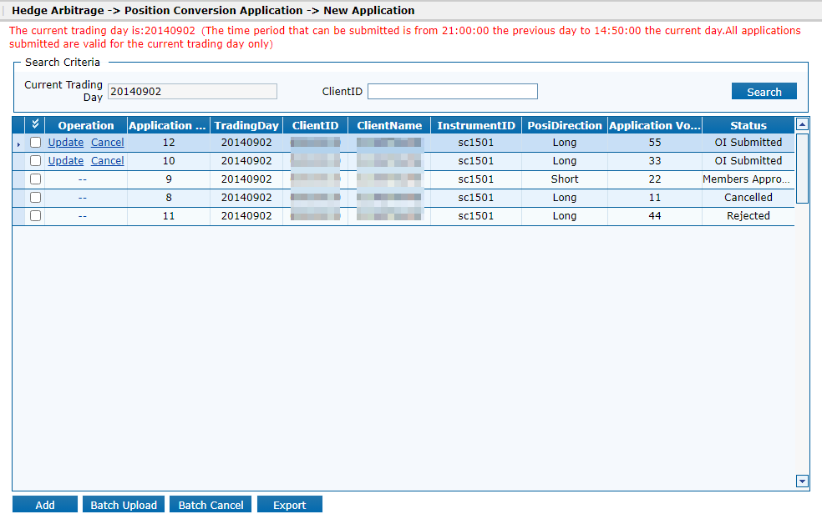

（Figure 3.1）

The operator can create, modify, revoke, batch import, batch revoke, or export position conversion applications via this page.



When creating a New Application, click the "**Add**" button at the bottom left of the above page (Figure 3.1) to go to the new interface (Figure 3.2). Enter the client ID, contract code, position direction, requested conversion quantity, then click "**Save**". The newly added application record will appear in the application list.

Note: After the client ID is entered, the system will automatically fill in the client name, eliminating the need for manual entry.

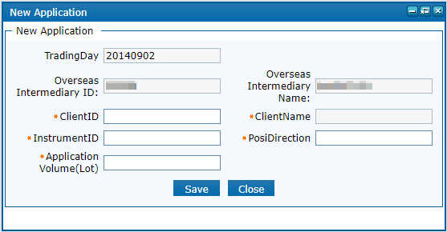

（Figure 3.2）

When modifying a position conversion application, select the record to modify, click the "**Update**" button in the operations column, edit the information on the new page (Figure 3.3), and click "**Submit**" after completion.

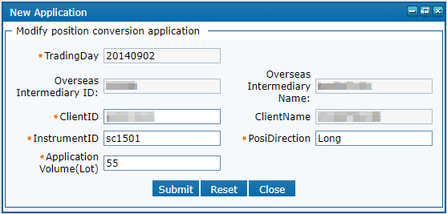

（Figure 3.3）

To revoke a position conversion application, select the record, click the "**Cancel**" button in the operations column. The system will prompt a confirmation dialogue (Figure 3.4); click "**OK**" to revoke the application.

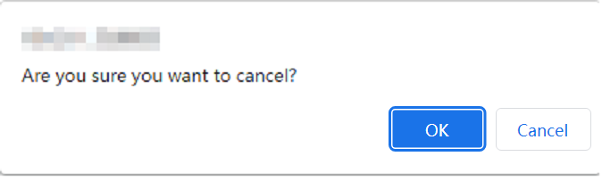

（Figure 3.4）

For batch revocation, select multiple records in the application list, click the "**Batch Cancel**" button at the bottom left of the page. The system will prompt a confirmation dialogue (Figure 3.5) showing the selected and qualifying record counts. Click "**OK**" after verification.

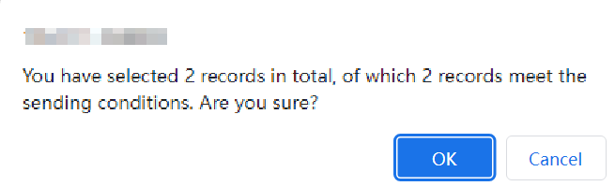

（Figure 3.5）

For batch import, click the "**Batch Upload**" button, select the file, and click "**Import**" in the pop-up window (Figure 3.6). Note: The imported CSV file must comply with the template format, which can be downloaded locally by clicking the "**Template**" button.

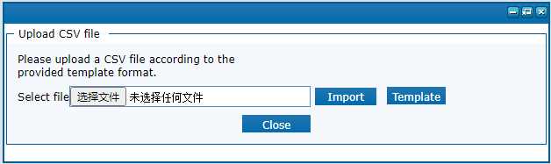

（Figure 3.6）

## Enquiry about Position Conversion Application

**Entrance: Hedge Arbitrage -> Position Conversion Application -> Application Enquiry**

The Application Enquiry interface (Figure 3.7) allows querying of member-submitted application records based on start and end trading days, client number, and status. Click "**Export**" to save the query results as an Excel file locally.

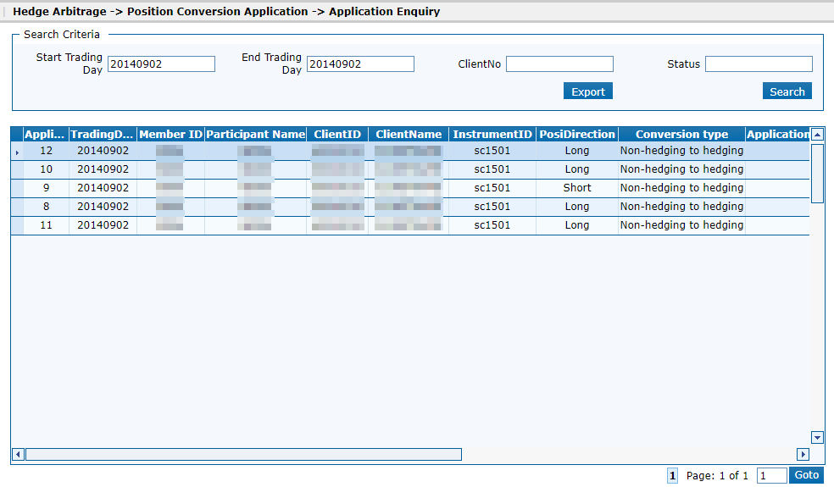

（Figure 3.7）

## INE Member Service System Front-end Operations

INE members' position conversion application includes the following operations:

* Position conversion application creating (refer to 3.1.1 Drafting Position Conversion Application)
* Application Enquiry (refer to 3.1.2 Application Enquiry)
* Forwarding position conversion applications submitted by overseas intermediaries

To forward position conversion applications submitted by overseas intermediaries, use the "**To do list**" on the right side of the page or navigate through the business window menu to proceed step by step.

**Entrance: General -> Overseas Intermediary Assessment -> Position Conversion Application**

The interface for the forwarding of overseas intermediary position conversion applications (Figure 3.8) allows querying of records submitted by overseas intermediaries based on start and end trading days, overseas intermediary ID, name, and status.

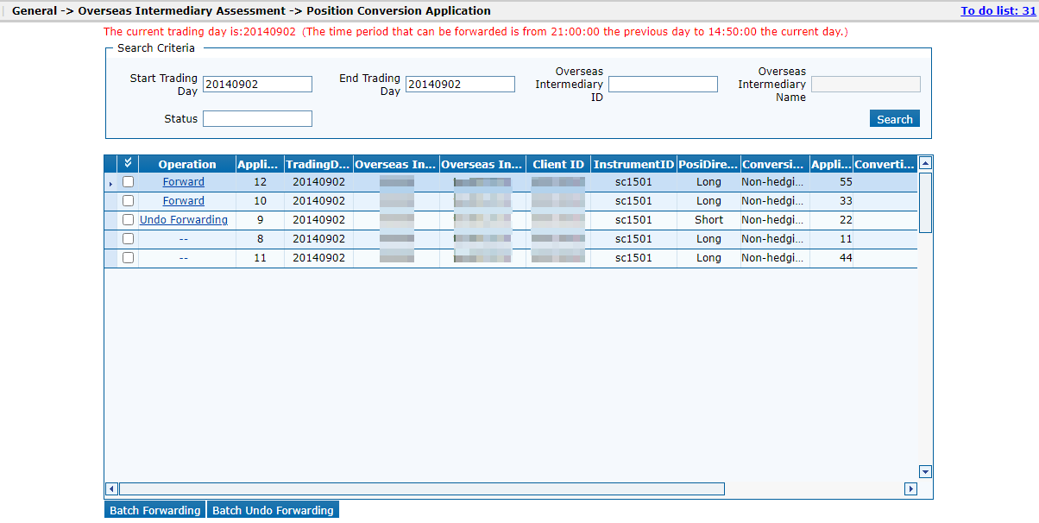

（Figure 3.8）

To forward a single application, select the record, click the "**Forward**" button in the operations column. A confirmation dialogue (Figure 3.9) will appear; click "**OK**" to submit the application to the Exchange.

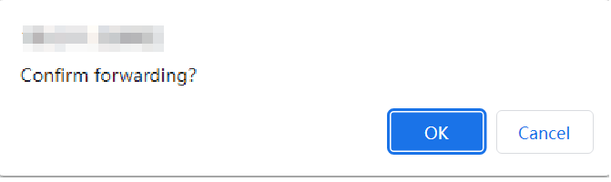

（Figure 3.9）

For batch forwarding, select multiple records, click the "**Batch Forward**" button at the bottom left. A confirmation dialogue (Figure 3.10) will show the total selected and qualifying records. Click "**OK**" after verification.

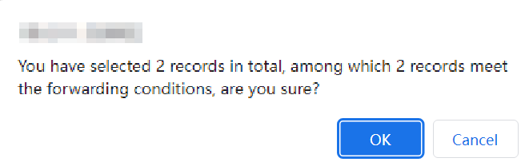

（Figure 3.10）

To revoke the forwarding of a single application, select the record, click the "**Cancel Forward**" button in the operations column. A confirmation dialogue (Figure 3.11) will appear; click "**OK**" to revoke the application.

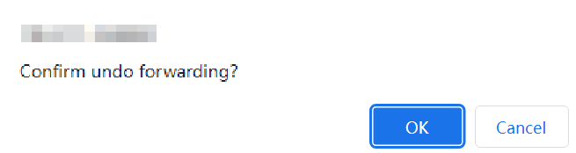

（Figure 3.11）

For batch revocation, select multiple records, click the "**Batch Undo Forward**" button at the bottom left. A confirmation dialogue (Figure 3.12) will show the total selected and qualifying records. Click "**OK**" after verification.

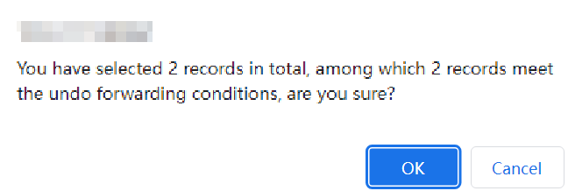

（Figure 3.12）

# Frequently Asked Questions

## Unable to Find Menu/Incomplete Menu Display

If after logging into the system, you cannot find the corresponding menu module, it may be that the login account used does not have the necessary permissions for this module's usage. Please contact the Exchange to verify the correctness of the login account information being used.